Nama : Anggi Dwi Darmawan

NPM : 085020036

Tugas Pemrograman Mobile 1

Link Github : https://github.com/anggidwidarmawan/anggi.git

1. Bicycle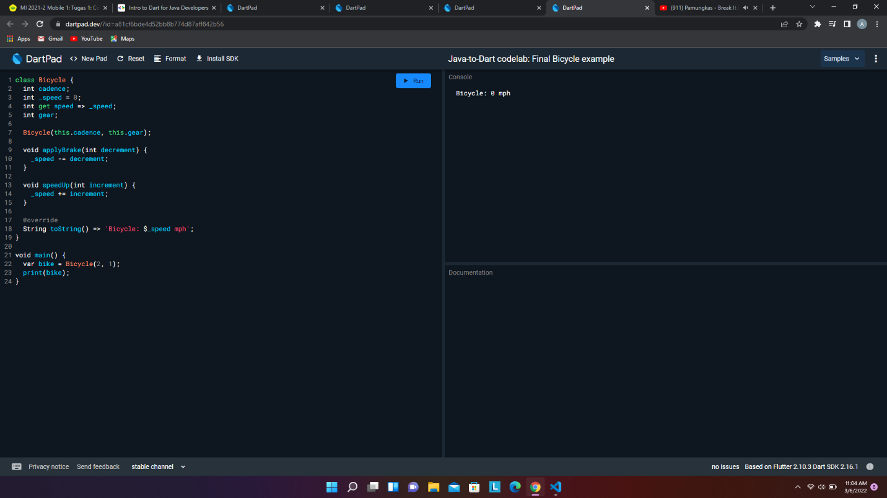
2. Rectangle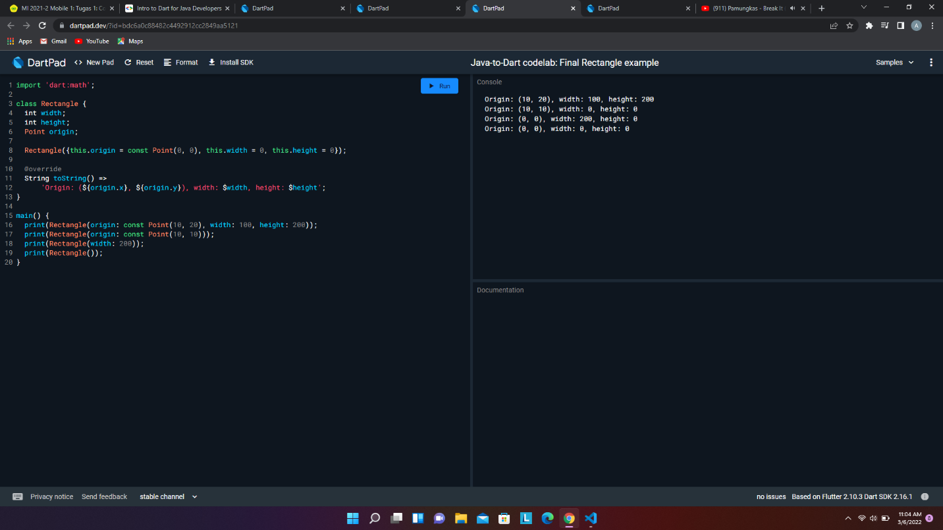
3. Factory Constructor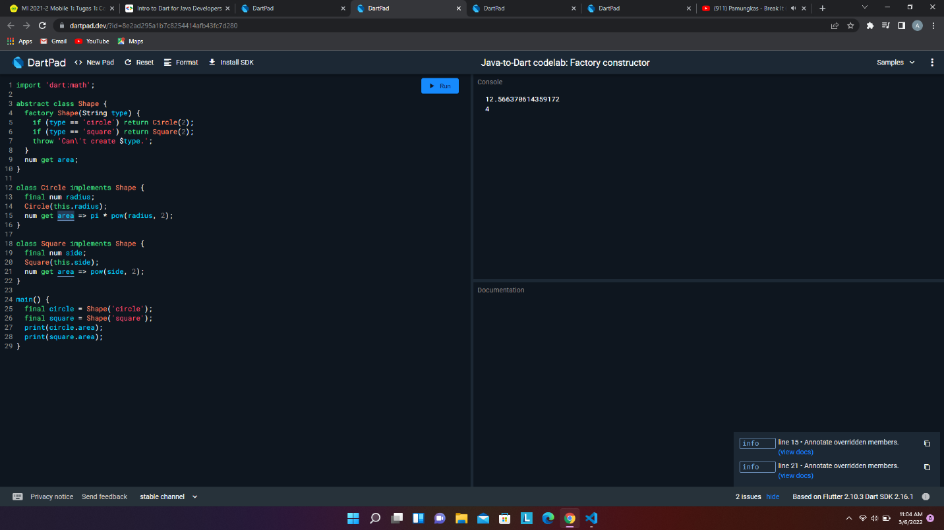
4. Circlemock Example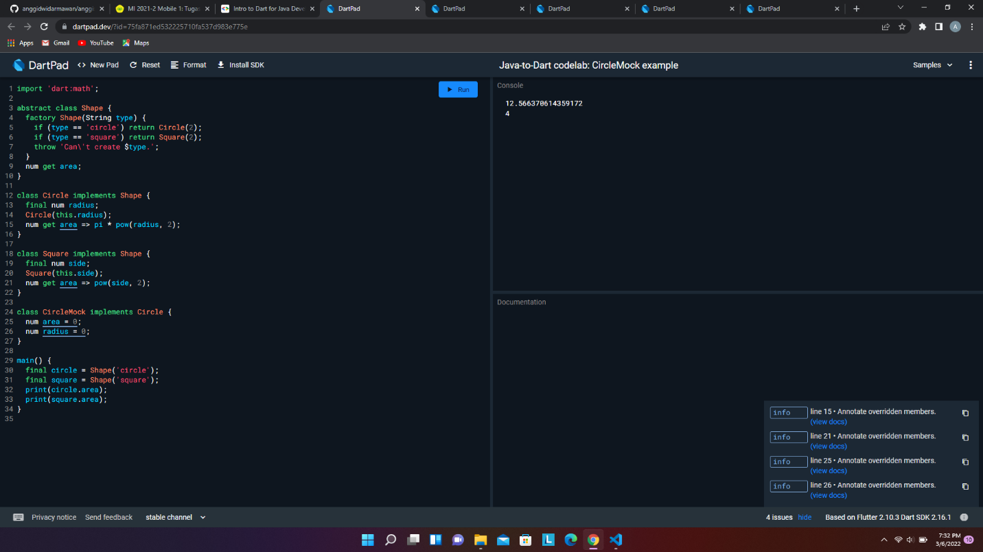
5. Scream Example